AD Group Creation

## Who can create??

1. Requester must be part of **SMWE - Active Directory Group Admins** to view the quick link.

## Steps

1. Navigate to Quicklink category ‘SMWE – AD Group Management’ and open quicklink ‘**Create AD Group**’

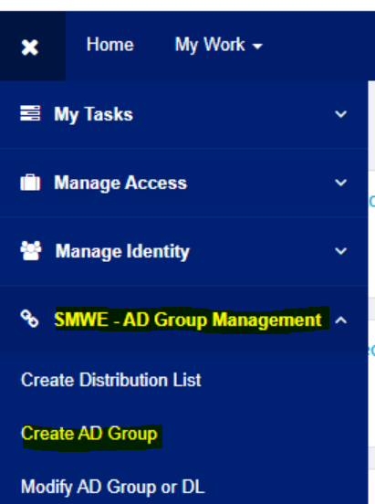

1. Fill below fields and click ‘Submit’
   1. Application name (*)
   2. Role Name (*)e
   3. Display name (*) – Combination of Application and Role name, will be populated automatically.
   4. Description – description of group
   5. Owner (*) – owner of the group. (managedBy attribute in AD)
   6. Requestable – if checked, users can raise an access request from SailPoint UI
   7. Privileged – maintained in SailPoint only.
   8. Privacy - maintained in SailPoint only
2. 1st Level Business Approvers – if configured, this identity will receive an approval work item, when the group is requested.
3. 2nd Level Business Approvers - if configured, this identity will receive an approval work item (after completion of 1st level approval) when the group is requested.

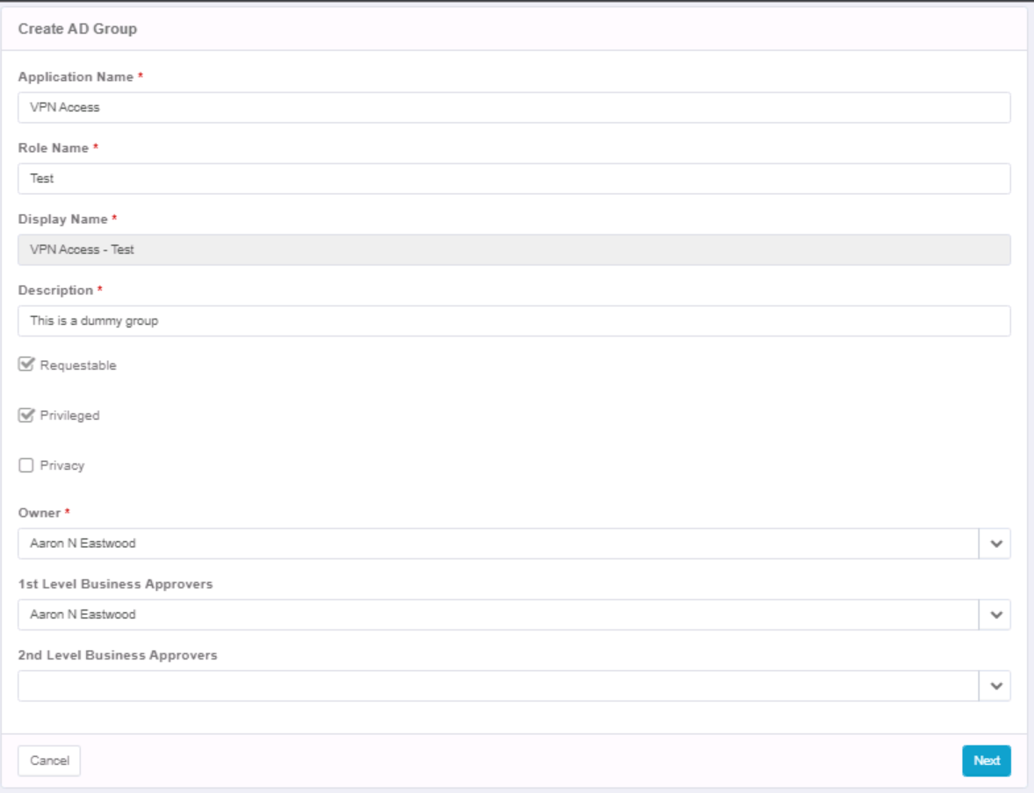

1. Verify the group details and click on submit button.

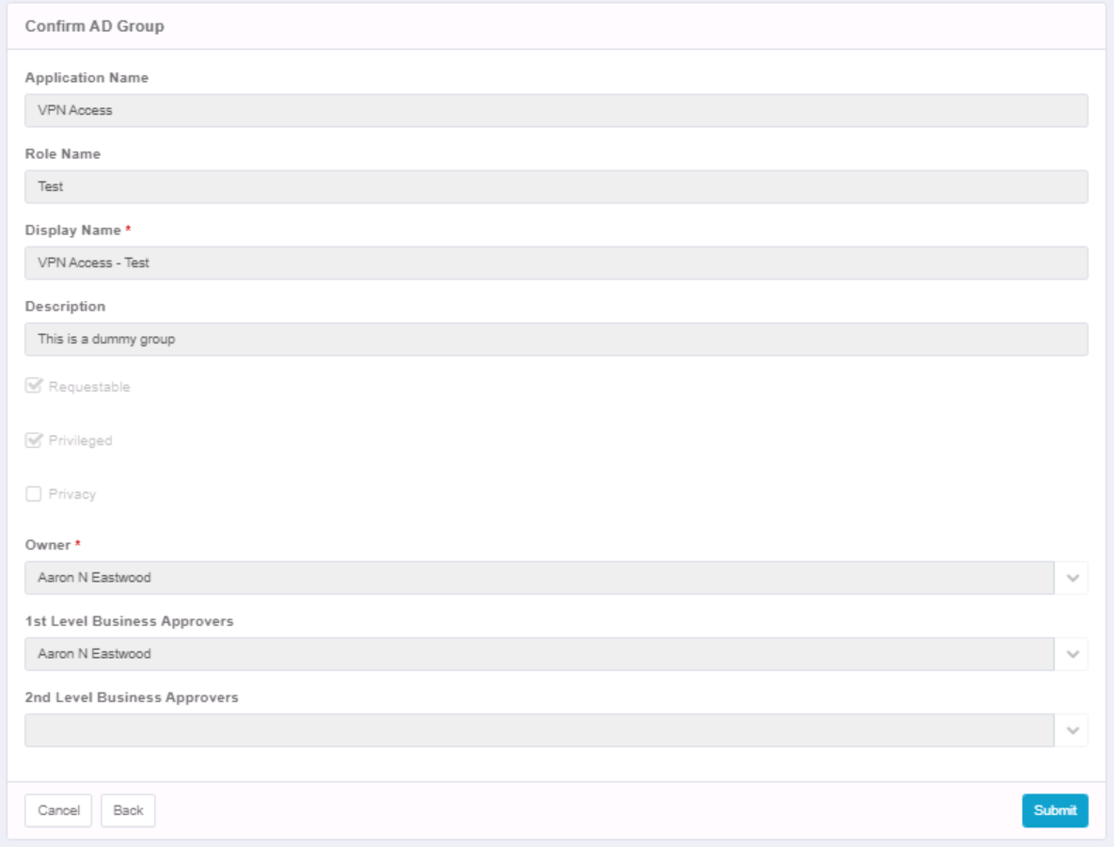

## Viewing newly created group in SailPoint

Go to ‘Applications’ >> ‘Entitlements Catalog’ >> Search for create group –

